Lab 2: Setting Up the Database Context for a Retail Store
Scenario: The retail store wants to store product and category data in SQL Server.

Steps:
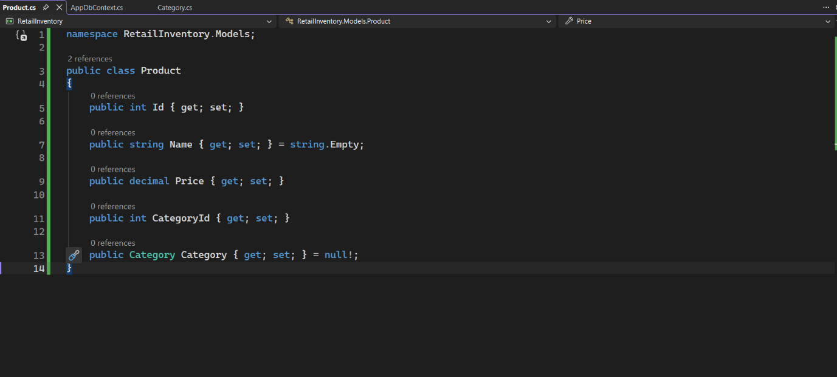
- Create Models:
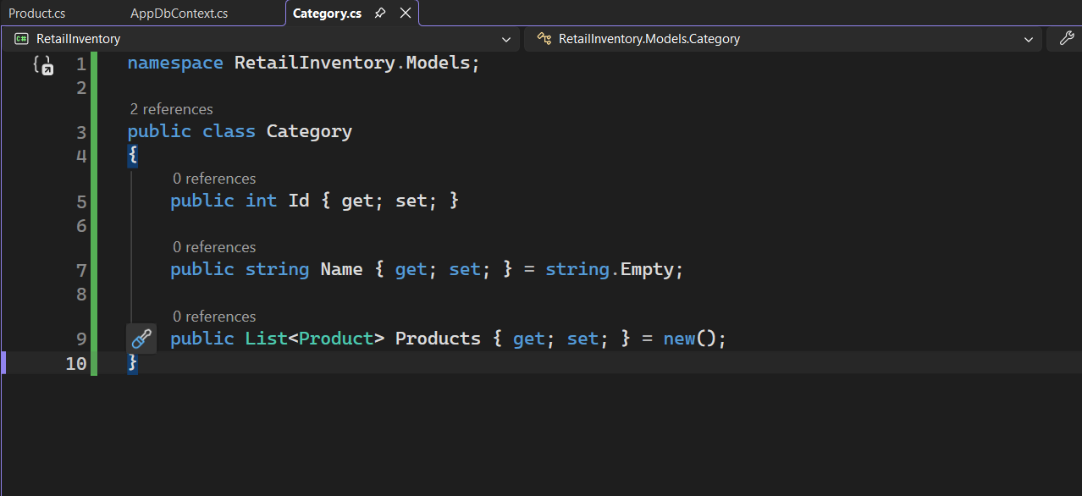

- Create AppDbContext:
